**Comparative Study of Pyro-Oil Yield from Individual Plastics vs. Mixed Plastic Waste**



**8th SEMESTER PROJECT WORK**

**PRE-FINAL PROJECT WORK (19CH7DCPPW)**

**FIRST PRESENTATION REPORT**

***Submitted by***

|  |  |
| --- | --- |
| **Hardik Verma** | **1BM20CH021** |
| **Manas Sooden** | **1BM20CH027** |
| **Pranay C** | **1BM20CH034** |
| **Prerak Shukla** | **1BM20CH036** |

***in partial fulfillment for the award of the degree of***

**BACHELOR OF ENGINEERING**

***in***

**CHEMICAL ENGINEERING**

***Under the Guidance of***

**Dr. Sreelakshmi Diddi**

**Assistant Professor**

**Department of Chemical Engineering**



**B.M.S. COLLEGE OF ENGINEERING**

**(Autonomous Institution, Affiliated to VTU)**

**BENGALURU-560019**

**March 2024**

**Comparative Study of Pyro-Oil Yield from Individual Plastics vs. Mixed Plastic Waste**



**8th SEMESTER PROJECT WORK**

**FINAL YEAR PROJECT WORK (19CH7DCPPW)**

**FIRST PRESENTATION REPORT**

***Submitted by***

|  |  |
| --- | --- |
| **Hardik Verma** | **1BM20CH021** |
| **Manas Sooden** | **1BM20CH027** |
| **Pranay C** | **1BM20CH034** |
| **Prerak Shukla** | **1BM20CH036** |

***in partial fulfillment for the award of the degree of***

**BACHELOR OF ENGINEERING**

***in***

**CHEMICAL ENGINEERING**

***Under the Guidance of***

**Dr. Sreelakshmi Diddi**

**Assistant Professor**

**Department of Chemical Engineering**



**B.M.S. COLLEGE OF ENGINEERING**

**(Autonomous Institution, Affiliated to VTU)**

**BENGALURU-560019**

**March 2024**

# BONAFIDE CERTIFICATE

This is to certify that the report titled, ‘**Comparative Study of Pyro-Oil Yield from Individual Plastics vs. Mixed Plastic Waste’** is a bonafide record of the Pre-final Project Work (19CH7DCPPW) carried out by the group of students during the academic year 2023-24. The students carried out this work as a member of the Pre-final Project Work Group are:

|  |  |  |  |
| --- | --- | --- | --- |
| **Sl. No.** | **Student Name** | **USN** | **Student’s Signature** |
| **1** | Hardik Verma | 1BM20CH021 |  |
| **2** | Manas Sooden | 1BM20CH027 |  |
| **3** | Pranay C | 1BM20CH034 |  |
| **4** | Prerak Shukla | 1BM20CH036 |  |

**Guide: Head of the Department:**

**Dr. Sreelakshmi Diddi Dr. Y K Suneetha**

**Assistant Professor Department of Chemical**

**Engineering**

**Signature: Signature:**

**Submitted for the University Examination held on: -**

**Internal Examiner External Examiner**

**Signature: Signature:**

# ACKNOWLEDGEMENTS

We would like to extend our heartfelt appreciation to Dr. Sreelakshmi Diddi, our guide, for her dedicated guidance, which has been instrumental in shaping our project. Gratitude is also due to the project coordinators, Dr. G. N. Rameshaiah and Dr. Sanjay Kumar, for their valuable insights and support.

Our sincere thanks go to Dr. Y. K. Suneetha, the Head of the Department, for her leadership and encouragement. We are also grateful to the entire department staff and the BMSCE management for providing us with the opportunity to work on this project. Their support has been pivotal in the successful completion of our endeavors.

# ABSTRACT

With an estimated annual generation of nearly 10 billion tons of plastic waste, this research addresses the critical need for sustainable waste management. The project delves into the conversion of plastic waste into a viable fuel source through pyrolysis. The focus involves a comprehensive analysis of the conversion process, from the collection of diverse plastic waste sources to the subsequent transformation into pyro-oil. By comparing the yield obtained from individual plastic types against mixed plastic waste, the study aims to determine the most efficient ratio of plastics to use for generating sustainable fuel. The findings from this comparative analysis aim to offer crucial insights into optimizing the conversion process, enabling innovative solutions for managing and repurposing the substantial volume of plastic waste and a scope for finding better separation techniques, thereby contributing to a more sustainable and eco-friendly approach to waste management and resource utilization.

# TABLE OF CONTENTS

|  |  |
| --- | --- |
| **TITLE** | **PAGE NO.** |
| **BONAFIDE CERTIFICATE FOR STUDENTS** | **i** |
| **ACKNOWLEDGEMENTS** | **ii** |
| **ABSTRACT** | **iii** |
| **TABLE OF CONTENTS** | **iv** |
| **LIST OF TABLES** | **v** |
| **LIST OF FIGURES** | **v** |
| **NOMENCLATURE** | **vi** |

|  |  |  |
| --- | --- | --- |
| **CHAPTER NO.** | **TITLE** | **PAGE NO.** |
| **1** | **INTRODUCTION** | **1** |
| **1.1** | **BACKGROUND OF THE PROJECT WORK** | **2** |
| **1.2** | **PLASTIC WASTE MANAGEMENT TAKING PLACE WITHIN INDIA** | **3** |
| **1.3** | **PLASTIC WASTE MANAGEMENT TAKING PLACE GLOBALLY** | **4** |
| **2** | **LITERATURE SURVEY** | **5** |
| **2.1** | **LITERATURE REVIEW** | **6** |
| **2.2** | **AIM AND OBJECTIVE OF PROJECT WORK** | **12** |
| **3** | **METHODOLOGY** | **15** |
| **4** | **CHARACTERIZATION** | **17** |
| **5** | **BUDGET ESTIMATION** | **23** |
| **6** | **CONCLUSION** | **24** |
| **7** | **REFERENCES** | **25** |

# LIST OF TABLES

|  |  |  |
| --- | --- | --- |
| **TABLE NUMBER** | **NAME OF THE TABLE** | **PAGE NO.** |
| 1 | Properties of liquid fuel from pyrolysis of single plastic feed | 7 |
| 2 | Physical properties of fuel derived from waste plastics | 9 |
| 3 | Budget Estimation | 23 |

# 

# LIST OF FIGURES

|  |  |  |
| --- | --- | --- |
| **FIGURE NUMBER** | **NAME OF THE FIGURE** | **PAGE NO.** |
| 1 | Plastic released into the ocean by rivers in Karnataka | 3 |
| 2 | Major regions where plastic is released into the ocean | 4 |
| 3 | Pyrolysis Experimental setup | 8 |
| 4 | Pyro oil | 21 |
| 5 | PET Segregation | 21 |
| 6 | Manual Segregation | 22 |
| 7 | Shredding of Plastic | 22 |
| 8 | Solid Char | 22 |

# 

# NOMENCLATURE

CO2 - Carbon dioxide

℃ - Celsius

PET - Polyethylene Terephthalate

PP - Polypropylene

LDPE - Low-density Polyethylene

HDPE - High-density Polyethylene

FTIR - Fourier transform infrared spectroscopy

TG - Thermogravimetry

DTG – Differential thermogravimetry

**CHAPTER 1**

# INTRODUCTION

## 1.1 BACKGROUND OF THE PROJECT WORK

Plastic pollution represents an ever-growing concern, impacting both human populations and the natural habitats of wildlife. Coastal communities alone contribute an estimated 1.1 to 8.8 million tonnes of plastic waste into the oceans annually, largely originating from post-consumer plastic packaging. Numerous studies have attempted to quantify the leakage of plastic into the environment, revealing the challenging task of pinpointing precise sources and volumes of this pervasive problem. Despite global initiatives to curb plastic waste generation, environmental losses are projected to surge. Current research forecasts an alarming trend: without substantial interventions, the ocean could witness an influx of 23 to 37 million tonnes of plastic waste annually by 2040, potentially escalating to 155 to 265 million tonnes by 2060. To counter this trend, pyrolysis emerges as a crucial process involving the thermal decomposition of materials, altering their chemical compositions. This method, commonly used in charring wood, employs heat, around 500 °C, without oxygen to convert plastics back into clean, sulfur-free oil. Though the concept of converting plastic waste into oil through pyrolysis isn't novel, it stands as a promising solution. With oil production declining and reserves depleting rapidly, the need for alternative energy sources intensifies. Pyro-oil, derived from this process, emerges as a potent substitute, especially within industrial sectors. Its high calorific value renders it a favorable alternative to conventional industrial fuels like furnace oil or industrial diesel. Pyro-oil not only serves as an energy source but also as a feedstock for refining diesel fuel through distillation. Its versatility holds value in regions facing scarcity in traditional oil resources, presenting a viable and sustainable solution amidst a landscape of high plastic pollution rates.

## 1.2 PLASTIC WASTE MANAGEMENT TAKING PLACE WITHIN INDIA

The Indian peninsula has been at the top of the list when it comes to waste disposal into the ocean. Among Indian states, Goa has been instrumental in converting plastic waste into fuel. Two plants in Goa’s Bicholim and Sonsoddo have been set up under the public private partnership (PPP) model with Bangalore-based M K Aromatics Ltd. Goa, which generates nearly 66 metric tons of plastic waste every day, has ample plastic waste converted to fuel. The two plants, functional since 2016, have been instrumental in converting 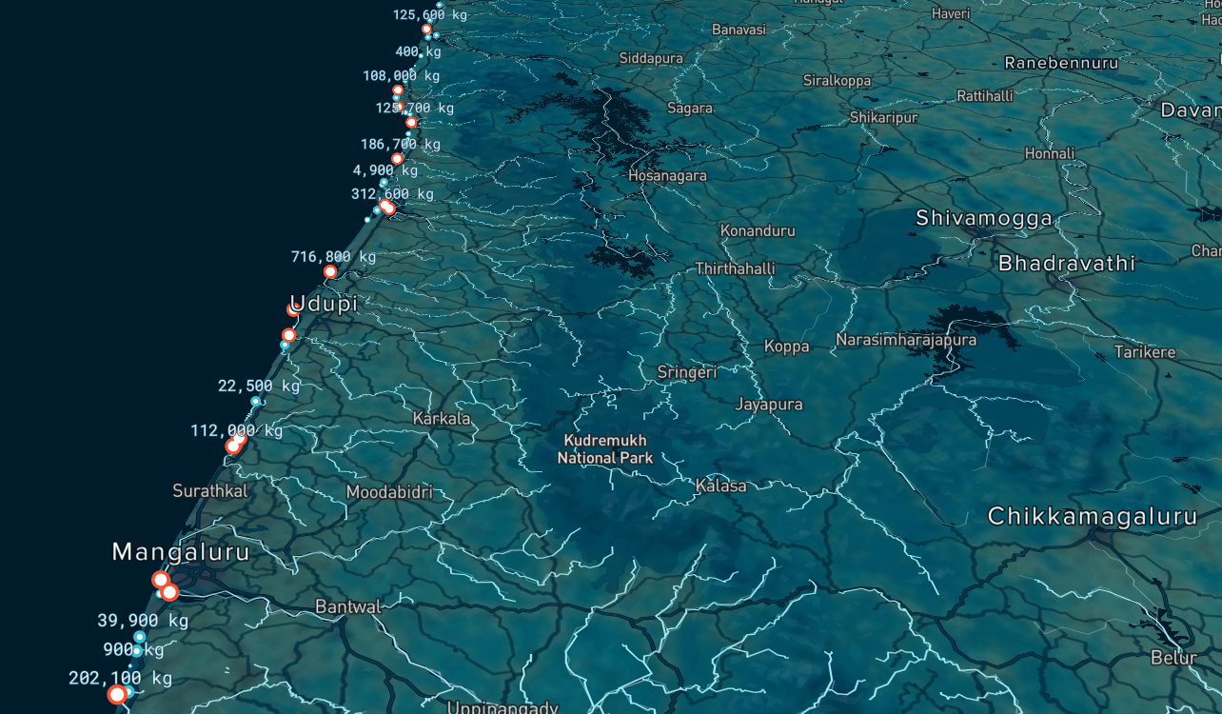plastic waste into fuel. The amount of Plastic disposed into the Ocean by rivers is best depicted by figure.1.

Figure 1:Plastic released into the ocean by rivers in Karnataka.

## 1.3 PLASTIC WASTE MANAGEMENT TAKING PLACE GLOBALLY

Around 400 million tons of plastic waste are produced by humans every year. That’s roughly the weight of all humans on the planet - and plastic production is projected to be going up. From this size, 9-10 million tons end up in the ocean annually. Not only this, when we account for plastic waste that is just thrown up in the dump yard, we will have a lot of plastic that is waiting to be converted into fuel. According to the plastics value chain mapping and assessment, “Egypt generates around 20 million tons of garbage and waste annually, with plastic waste assumed to represent 6% out of the total, distributed over Cairo (60%), Alexandria (16%), the Nile Delta (19%), and other regions including Upper Egypt, Suez Canal, and Sinai (5%). Out of the 970 kilotons of plastic waste generated annually, only a range of 30% is recycled, while 5% is reused, 33% is landfilled, and 32% is left to be burned. The total amount of plastic waste represents 10% of all garbage in Egypt. The amount of plastic that is neither collected nor landfilled is 65%. Countries like Japan, Germany and the United States have already implemented the plastic to fuel conversion process with much success. These three have also been successful in creating business models out of the conversion process, resulting in the conversion model becoming a profitable business one.

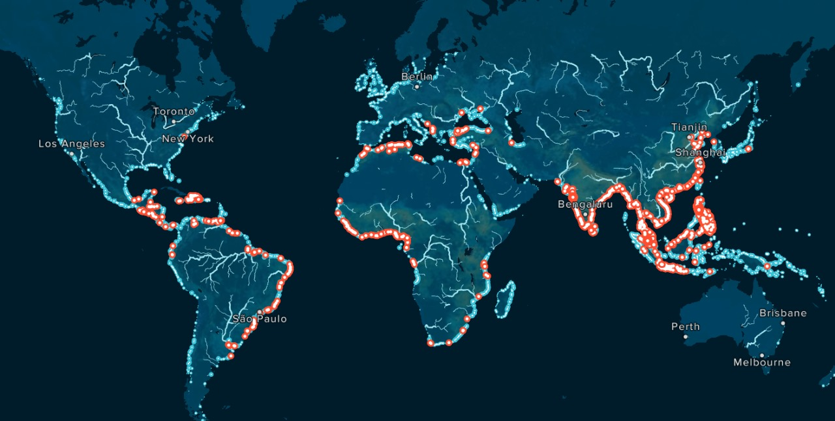

Figure 2:Major regions where plastic is released into the ocean.

**CHAPTER 2**

# LITERATURE SURVEY

# 

## 

## 2.1 LITERATURE REVIEW

**NOVEL TRENDS IN PLASTIC WASTE MANAGEMENT [1]**

As regards existing statistics, there is continual increase in plastics consumption because of its wide scope of applications, resulting in increased plastics waste. Plastics are applied in engineering, automotive, construction, medical, aerospace, electrical, robotics, and so on. The rapid growth in global economy and development has also improved the quest and reliance on these materials, resulting in its accumulation in landfills which poses danger to human and animal health, environmental pollution issues such as contamination of groundwater and sanitation challenges. Hence, an effective and sustainable route of treating these waste materials is critical to eliminating these challenges. Alongside the technical and environmental challenges of waste accumulation, there exists varying degrees of political, administrative, economic, and societal issues.

Plastic recycling includes both chemical recycling (pyrolysis) and incineration. The varying routes proposed for waste plastics recycling include primary and mechanical recycling. Primary recycling involves the in-plant waste recycling of scrap materials. Mechanical recycling involves separating plastics from its attendant contaminants and further processing via melting, shredding, or other similar procedures.

Pyrolysis is a thermochemical treatment method which can offer a panacea to these pollution challenges, in addition to recovering valuable energy, and products such as oil and gas. The pyrolysis of PSW has attained prominence, because of its numerous advantages channeled toward alleviating environmental pollution, and reducing plastic products carbon footprint through the minimization of carbon monoxide and carbon dioxide emission, in comparison to combustion and gasification.

Plastics re-utilization has some benefits including (i) fossil fuels conservation. This is because plastics production uses about 4–8% of global oil production, composed of 4% feedstock during conversion, (ii) energy reduction and MSW, and (iii) release of CO2, NOx, and SO2.

To conclude this research paper talks about the growing need for plastic management in depth as well as multiple ways of plastic management. Pyrolysis is one of the best methods suggested as it helps produce oil and fuel from plastics, helping reduce plastics and making useful fuel out of it.

**PLASTIC WASTE MANAGEMENT: A REVIEW OF PYROLYSIS TECHNOLOGY [2]**

Pyrolysis is the thermal degradation of plastic waste at different temperatures (300-900°C). This degradation turns the plastics into fuels. Pyrolysis can be slow, fast or flash depending upon the heating rate with slow giving mainly solid char, fast giving liquid fuel and flash giving gases and bio-oil as main products respectively.

Table 1: Properties of liquid fuel from pyrolysis of single plastic feed

|  |  |  |  |  |  |
| --- | --- | --- | --- | --- | --- |
| Plastic fuel | Density,40⁰C  (g/cm³) | Viscous  40⁰C | Flash Point(⁰C) | Calorific Value(mJ/kg) | Appearance |
| HDPE | 0.800-0.920 | 2.42-2.52 | 40-48 | 45.4 | Light oil, Brown |
| LDPE | 0.768-0.8020 | 1.65-1.801 | 50 | 39.1 | Light oil, Brown |
| PP | 0.767-0.8 | 2.72 | 31-36 | 40 | Light oil, Yellow |
| PET | 0.087-0.9 | NA | NA | 28.2 | Light oil, Brown |
| PS | 0.85-0.86 | 1.4 at 50⁰C | 28 | 43 | Light oil, deep Brown |

The advantages of using pyrolysis are its high heating value alongside its potential of being used for multiple types of feed. We also see their elemental analysis and notice the presence of sulphur and nitrogen alongside the usual suspects of carbon and hydrogen.

One of the few banes of using pyrolysis is the presence of high sulphur content in the liquid fuel, it being used in automobile industry would release sulphur dioxide in the air causing acid rain plus a low flash point which would mean high volatile compounds being present which are hard to transport.

Thus, we see what pyrolysis is, its advantages, disadvantages and seeing the properties of fuels obtained from pyrolysis of different plastics noting HDPE as one of the best sources of fuels among them.

**PYROLYSIS OF WASTE INTO FUEL [3]**

Pyrolysis is the process of thermal decomposition of plastics in an inert atmosphere and at a high temperature. In this process, the chemical composition of plastics is converted to hydrocarbon compounds and is an irreversible process. The plastics which are used in this process are mainly HDPE, PP, PE, and LDPE which are converted into fuel. The following setup was used for the process to take place.

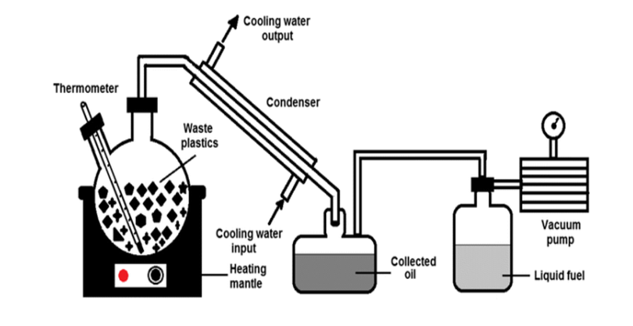

Figure 3:Pyrolysis Experimental setup

The container to be heated is kept on the fire with the test tubes or pipes connected to the container, a digital thermometer is used for measuring the temperature of the container(if needed), the test tubes are further divided for different separation and at the end of the test tube a container in which the fuel will collected is connected, a condenser(in some cases or if needed) is kept surrounded to the test tube for condensing the fuel and a pyrolizer for the process of pyrolysis. The plastic is put in the reactor and is heated at a constant temperature. The gases are evaporated and cooled in the condenser with the help of cool water. The condensed oil is collected, and fuel is obtained.

After carrying out the experiment we get to know about the physical properties of fuel waste plastic

Table 2:Physical properties of fuel derived from waste plastics.

|  |  |
| --- | --- |
| Characteristics | Fuel |
| Flash point(⁰C) | 81 |
| Fire Point (⁰C) | 90 |
| Viscosity (40⁰C) | 3.812 |
| Density(kg/m³) | 823 |
| Calorific Value(kJ/kg) | 46888 |

From the experiment, it can be concluded that burning 1 kg of plastic can easily yield 600 to 750 ml of diesel fuel. The characteristics of the fuel are noted and seen by turning plastic into fuel, we can reduce atmospheric CO2 emissions by 80% and burn 1 kg of plastic in the open atmosphere to produce up to 3 kg of CO2, thus solving both problems. The obtained waste plastic fuel has a higher efficiency than the available fuel in the market and the cost of production is 30% to 40% lower than other fuel production methods.

[**STUDY ON THE PYROLYSIS BEHAVIOR OF MIXED WASTE PLASTICS 4****]**

This study explores three types of waste plastics and their mixed forms to obtain thermal cracking features, products distribution, and kinetic features. TG analyzer and FTIR were used to observe the decomposition characteristics and functional groups in the volatile fractions of products. TG furnace was 1st heated at constant rate with temperature range 30-1500⁰C with mass of 10-15 mg. The products released from TG during the waste plastics pyrolysis process were blown to FTIR by capillary bundles with constant temperatures of 280⁰C and 230⁰C.

It was observed that the thermal decomposition of PS and PE started rapidly with both losing 90% wt with little residue and only having one step pyrolysis taking place at relatively lower temperatures, which meant PS had lower thermal stability than PE. PVC had two steps as it showed two DTG peaks. The first process mainly focused on breaking the C-Cl bond, which led to HCl formation. The second procedure mainly included molecular rearrangement, molecular cyclization, and molecular aggregation. The first peak of its TG curve went through 60 wt% weight loss, and the second peak experienced about 20 wt% weight loss.

For both PE and PS, volatile components after pyrolysis were hydrocarbons with mainly alkenes and some saturated hydrocarbons and alkynes. The products of PVC pyrolysis mainly focused on HCl and alkanes at the first stage, then alkenes and aromatic compounds at the next stage.

During the co-pyrolysis of PS with PE, the thermal decomposition of PS was restrained by PE. While for the mixtures of PS with PVC, PS had more rapid cracking rates than pure components. PS and PE both had positive effects during the co-pyrolysis process with PVC. Also from kinetic parameters, we see that all 3 pyrolysis were 1st order reactions.

To conclude, PE and PS showed similar behaviors to pyrolysis as they both decompose in one step releasing mainly alkenes with saturated hydrocarbons and alkynes, losing around 90% wt while PVC had a two-step process releasing HCL and alkanes in the first step losing 60% wt and alkenes and aromatics in the second step losing 20% wt. All 3 reactions were 1st order reactions. PS and PE restrain thermal decomposition with each other while both with PVC showed positive effects i.e., better decomposition.

[**ECONOMIC ANALYSIS OF UNCONVENTIONAL LIQUID FUEL SOURCES [5]**](#_Mehmet_Erturk.(2011).Economic_Analy)

The main area of focus undertaken in this review article is on evaluating the potential of alternative liquid fuel sources to enter the market based on their cost structures. It discusses the historical dominance of gasoline and diesel produced from conventional oil and highlights the relatively limited success of other materials like coal, biomass, and natural gas in the fuel market, with some exceptions in certain regions. Recent interest in unconventional fuel sources has resurfaced due to increased oil prices, prompting some countries to produce liquid fuels from alternative sources. This revival of interest is primarily observed in countries with competitive advantages in terms of source availability. The term "unconventional liquids" encompasses syncrude, synthetic fuels, and renewable fuels. Syncrude is derived from bitumen in oil sands or shale oil. Shale oil has gained popularity, especially in the USA, as an alternative to crude oil. Synthetic fuels are produced through processes such as coal-to-liquid (CTL), gas-to-liquid (GTL), and biomass-to-liquid (BTL). CTL technologies include pyrolysis, direct coal liquefaction, and indirect coal liquefaction. GTL involves converting natural gas into longer-chain hydrocarbons. BTL technology produces synthetic gases from non-food plant sources. Different cost structures exist for these unconventional liquid fuels, affecting their market entrance prices. Market entrance and shut-down prices are essential cost components for these sources. The market entrance price covers operating costs and provides the expected rate of return to investors. The shut-down price determines the price level at which production stops.

The study delves into the structure of the liquid fuel market, discussing the characteristics of a competitive market and considering factors such as the number of producers, market entry barriers, and the impact of OPEC (Organization of the Petroleum Exporting Countries) on market structure. Unconventional liquid fuels, while alternatives to crude oil, face higher production costs compared to conventional fuels. They become economically competitive only when crude oil prices rise. The analysis of various sources indicates that biofuels, despite their advantages in market entrance and shut-down prices, have more economic potential. GTL presents an attractive option but requires a substantial initial investment. Syncrude sources are competitive but have high capital costs, making them less attractive. CTL is the least preferable due to high market entrance prices, capital costs, and low shut-down prices, posing high risk in an unstable market.

To conclude, the study underscores the potential of unconventional liquid fuel sources as alternatives to conventional oil by evaluating market structures, capital costs, and price criteria, presenting biofuels as the more advantageous option compared to other sources.

## 2.2 AIM AND OBJECTIVE OF PROJECT WORK

**Aim**:

The aim of this project is to conduct a literature survey for a comparative analysis of the Pyro-Oil Yield from individual types of plastics and mixed plastic waste.

**Objectives**:

1. Collection and segregation of distinct plastic types such as Polyethylene Terephthalate (PET), Polypropylene (PP), Low-Density Polyethylene (LDPE), and High-Density Polyethylene (HDPE)
2. Pyrolysis of the plastic waste for generating pyro-oil.
3. Comparison of the properties and conversion efficiency of individual and mixed plastic waste to pyro-oil.

**2.3 PLASTIC TYPES BEING USED**

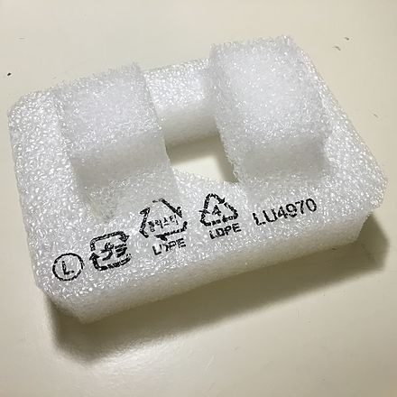Low-density polyethylene (LDPE) is a type of thermoplastic made from monomer ethylene, it has low melting point and is known for its flexibility, transparency, toughness and packaging applications. Some common examples include squeezable bottles, garbage bags, plastic gloves, and single-use containers.

*Figure 4: a) A piece of packaging foam made from LDPE*. *b)* *A Ziploc bag made from LDPE*

High-density polyethylene (HDPE) is a thermoplastic polymer produced from the monomer ethylene. With a high strength-to-density ratio, HDPE is used in the production of plastic bottles, corrosion-resistant piping, geomembranes and plastic lumber. Some common examples of HDPE are plastic bottles, milk jugs, shampoo bottles, bleach bottles, cutting boards, and piping.

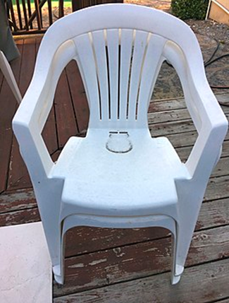

*Figure 5: a) HDPE jerry cans resist softening and swelling from aromatic components of fuels. b)* *The monobloc chair made using HDPE*

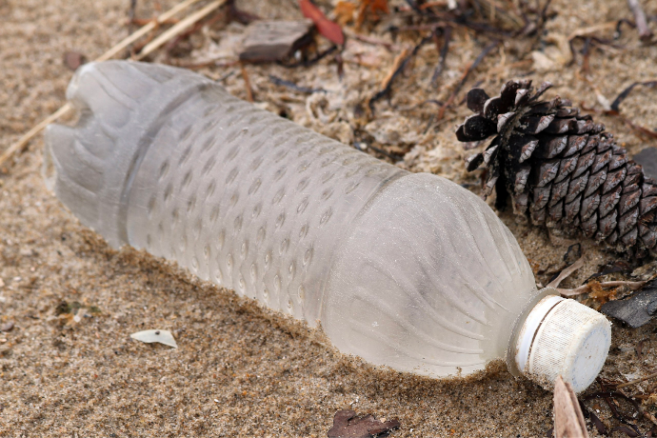Polyethylene terephthalate (PET) is the most common thermoplastic polymer resin of the polyester family and is used in fibers for clothing, containers for liquids and foods, and thermoforming for manufacturing, and in combination with glass fiber for engineering resins.

*Figure 6: A finished PET bottle*

Polypropylene (PP), also known as polypropene, is a thermoplastic polymer used in a wide variety of applications. It is produced via chain-growth polymerization from the monomer propylene.

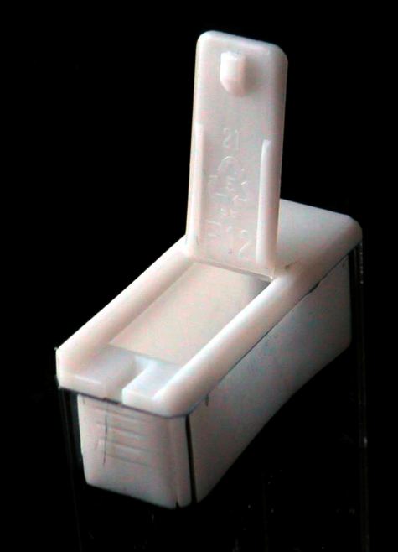

*Figure 7: a) Polypropylene lid of a Tic Tac box*. *b) Bottle caps made using Polypropylene*

## 2.4 MATERIALS AND APPARATUS:

1. **Variety of Plastics**: Various plastics obtained from multiple households and hotels, i.e. LDPE, PP, HDPE, PET.
2. **Pyrolizer**: The primary reactor for thermal degradation of Plastics.
3. **Test tubes or glass bottles**: To collect samples, aiding separation, and analysis of pyrolysis oil.
4. **Water and ice cubes:** They will be used as cooling agents to condense the oil vapors.

# 

# CHAPTER 3

# METHODOLOGY

# METHODOLOGY

**3.1 Preparation:**

1. **Plastic Segregation:** Different types of plastics will be meticulously sorted and segregated based on their material composition. Various plastics are obtained from multiple households which include, i.e. LDPE, PP, HDPE, PET. Standardize particle size (1-5 cm) using manual crushing and shredding.
2. **Reactor Setup:**

Choose an appropriate reactor material (e.g., high-temperature resistant stainless steel) with sufficient capacity.Ensure seals meet high-temperature and inert atmosphere requirements.

1. **Calibration and Maintenance:**

Calibrate all measurement instruments (thermometers, Temperature and pressure monitor controller).

**3.2****Experimentation:**

1. **Sample Loading:** Introduce 1 kg of pre-cleaned plastic into the reactor. Consider pre-treatment like drying to remove moisture.
2. **Temperature Control:** Set the furnace/reactor controller to maintain 300°C with precise regulation (±1°C).Implement a controlled heating rate of 10°C/minute.Monitor and record temperature data throughout the experiment.
3. **Reaction:** Run the experiment for a duration of 30-45 minutes.Consider exploring staged or segmented heating profiles (250 - 500°C) for potential product selectivity enhancement.
4. **Product Collection:** Allow the system to cool down under room temperature and atmospheric pressure conditions.Separate the oil-water mixture using a separatory funnel.
5. **Product Characterization:** Characterize the pyro oil based on essential properties such as viscosity, density, conversion yield, and calorific value for detailed composition analysis.
6. **Repeatability:** Conduct replicate experiments to assess and report statistical variance in results.Compare results with control experiments using virgin plastics.
7. **Results:** Determining an optimal plastic composition ratio to maximize conversion yield.

# 3.3 Characterization:

1. **Density:**

The specific gravity measurement is conducted to assess the mass per unit volume of pyro oil in comparison to water. This information is vital for understanding the overall density of the fuel. Density, in turn, influences the feasibility of storing and transporting pyro oil.

Test Method: Specific Gravity Measurement

Procedure: Fill a specific gravity flask with pyro oil, measure its weight, and compare it to the weight of an equal volume of water. This helps determine the density of the pyro oil relative to water.

1. **Viscosity:**

The viscometer test is performed to quantify the flow behavior and resistance of pyro oil. This information is crucial for assessing the suitability of the fuel for various applications. Understanding viscosity guides the design of processing equipment and ensures optimal performance in practical scenarios.

Test Method: Redwood Viscometer

Procedure: The liquid is added to the viscometer, pulled into the upper reservoir by suction, and then allowed to drain by gravity back into the lower reservoir. The time that it takes for the liquid to pass between two etched marks, one above and one below the upper reservoir, is measured. If the level of the liquid having density ρ is initially at h1 and finally at h2 the mean hydrostatic pressure during the outflow is:  where g is the gravitational acceleration of free fall. For absolute measurement we have to know all parameters of the viscometer (V, r, l, h1, h2) but we can calibrate the equipment using a reference liquid having well known density ρ0. The relative viscosity is: where ρ is the density, t is the time of outflow of the sample, ρ0 is the density, t0 is the time of the outflow of the reference liquid (water), η0 the viscosity of the sample can be calculated.

1. **Calorific Value:**

The bomb calorimeter test is conducted to determine the heat released during the combustion of pyro oil. This information is essential for evaluating the energy content of the fuel. Calorific value data is crucial for understanding the efficiency of the fuel and its potential applications in various industries.

Test Method: Bomb Calorimeter

Procedure:

1. A Liquid fuel sample is taken and compressed into a briquette using the briquette and is weighed accurately.
2. The briquette is placed into the crucible. The fuse wire of 0.1mm diameter and 100mm length is attached to the ignition rods and the crucible is swung around until the loop of the wire touches the briquette.
3. The oxygen cylinder is coupled to the bomb till the pressure in the bomb rises to 30 kg/cm2 with the release valve closed position. The charged bomb is placed in the calorimeter filled with 1500 cc of water.
4. The stirrer is fixed. When the bomb and its contents attain a steady temperature, the electric supply is switched on to ignite the fuel.
5. The maximum rise in temperature of the water was recorded. The stirrer was kept in motion all the time. The products of combustion were recorded. The stirrer was kept in motion all the time. The products of combustion were released with the help of the release valve.
6. Unburnt fuse wire was collected and weighed.

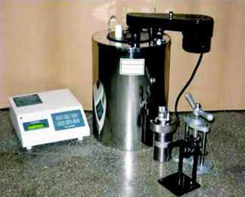

Figure 8: Bomb Calorimeter

1. **Conversion Yield:**

The conversion yield calculation is performed to assess the efficiency of the pyrolysis process, determining the amount of pyro oil produced per unit of feedstock. This information is critical for process optimization, resource management, and evaluating the overall sustainability of the production method, via this information we would be able to figure out the optimum ratio achieved for the maximum conversion yield. Multiple iterations with different ratios of LDPE, PP, PET and HDPE need to be carried out for obtaining the favourable ratio of these four leading to maximum conversion yield.

Test Method: Calculation based on measurement via Volumetric flask.

Procedure:

1. The Pyro oil produced is collected into a glass bottle.
2. Measurement of the obtained fuel is noted down using the graduations on the bottle.
3. This calculation provides a quantitative measure of the conversion yield, as per the basis for pyrolysis feedstock for 500g.

# Progress Made So Far

1. Collection of Variety of Plastic: Different plastic’s like HDPE, LDPE, PP, PET were collected from the plastic segregator company near Chellangatta, South Bengaluru.
2. Shredding the Plastic: We went to AZ Plastic for shredding the collected Plastic at a size lower than 2cm.
3. Distribution network of Plastic: Understood the initial segregation of plastic from collecting from the landfills to the distribution network included in it.
4. Iterations: Conducted multiple iterations for pyrolyses process of PET and PP by regulating the temperature using a PID controller and at temperature of 5 – 10 ℃ / min.
5. Pyrolysis of PP: Formation of a semi-solid lubricant(wax) was observed after the condensation of vapors inside the collector filled with ice-water, the cause of this lubricant formation is sudden drop in the temperature of the vapors.
6. Pyrolysis of PET: the first iteration was conducted with PET, which produced low amount of char and high amount of gaseous vapors as per the weight percentage.
7. Flash Point: the wax collected from the pyrolysis of PP was flammable with higher flash point compared to PET.
8. Weight: Around 250 gm of wax was produced with 500gm of PP, which was operated at the temperature of 450 °C whereas for PET the operational temperature was 310 °C.

Figure 9: Pyro Oil.

Figure 10: PET Segregation.

Figure 11: Manual Segregation.

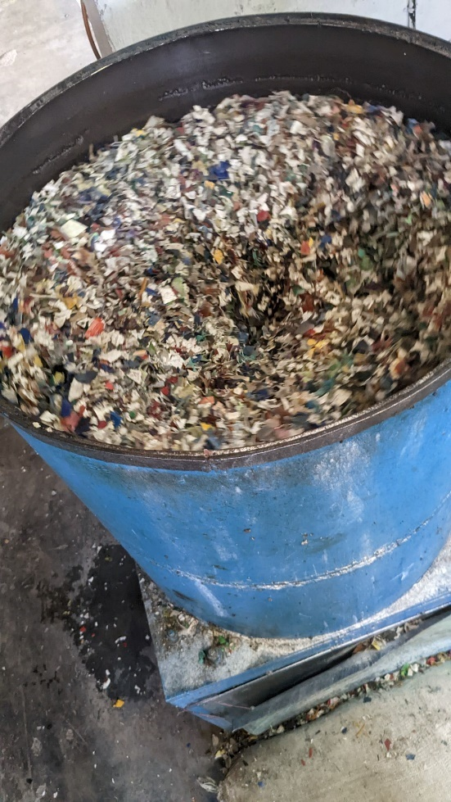

Figure 13: Solid Char

Figure 12: Shredding of Plastic

# BUDGET

|  |  |  |  |
| --- | --- | --- | --- |
| **S.No.** | **Materials and Services** | **Quantity** | **Expenses (INR)** |
| **1.** | **Plastics** | **1 Kg** | **₹ 600** |
| **2.** | **Pyrolyser** | **—** | **₹ 32000** |
| **3.** | **Ice Cubes** | **15 Kg** | **₹ 600** |
| **4.** | **Glass Bottles** | **5 Bottles** | **₹ 1,495.00** |
| **5.** | **Bomb Calorimeter** | **—** | **₹ 40000** |
| **6.** | **Redwood Viscometer** | **—** | **₹ 10000** |
|  | **NET EXPENSES** | | **₹ 84695** |

# 

# CONCLUSION

By analyzing and comparing the constituents of various plastics, the project aimed to identify optimal combinations, foreseeing the purpose of achieving the highest possible conversion yield. This sought-after yield, particularly in the form of pyro-oil, holds promise as a sustainable and crucial fuel source for various industrial operations. Moreover, the project heralds a new chapter in recycling methodologies by pushing the boundaries of waste separation techniques. Its core ethos lies in the transformative process of converting a substantial volume of plastic waste into valuable, usable products. This endeavor, aiming to address the alarming demands for sustainable solutions, represents a monumental step towards a more environmentally conscious future. The urgency to explore alternative fuel sources is underlined by the rapid depletion of traditional energy reserves, and this project’s focus on converting plastic waste into usable fuel stands as a pivotal opportunity to meet this need. In essence, this project not only grapples with the pressing challenge of plastic pollution but also presents a visionary pathway towards sustainability. Its outcomes signify a paradigm shift in waste management practices, offering pragmatic and applicable solutions that not only mitigate environmental concerns but also pave the way for a more sustainable, eco-friendly future, aligning with the global commitment to a greener, cleaner planet. The future scope of this project encompasses deeper exploration and fine-tuning of optimal plastic combinations to enhance conversion yields, an emphasis on refining waste separation techniques for improved recycling processes, and the potential for expanding the applications of pyro-oil as a sustainable energy source across various industries. Moreover, the project’s future trajectory involves scaling up the developed methodologies for practical implementation, potentially initiating pilot projects or collaborative ventures with industry stakeholders to assess feasibility on a larger scale.

# 

# REFERENCES

1. Idumah, Christopher Igwe, and Iheoma C. Nwuzor. “Novel Trends in Plastic Waste Management.” *SN Applied Sciences*, vol. 1, no. 11, 15 Oct. 2019, https://doi.org/10.1007/s42452-019-1468-2.
2. Eze, Wilson Uzochukwu, et al. “Plastics Waste Management: A Review of Pyrolysis Technology.” *Clean Technologies and Recycling*, vol. 1, no. 1, 2021, pp. 50–69, https://doi.org/10.3934/ctr.2021003.
3. Ram Jatan Yadav, Shivam Solanki, Sarthak Saharna. “Pyrolysis of Waste Plastic into Fuel.” *International Journal of Recent Technology and Engineering*, vol. 9, no. 1, 30 May 2020, pp. 2600–2605, https://doi.org/10.35940/ijrte.a2662.059120.
4. Li, Dan, et al. “*Study on the Pyrolysis Behaviors of Mixed Waste Plastics.*” Renewable Energy, vol. 173, no. C, 2021, pp. 662–674, ideas.repec.org/a/eee/renene/v173y2021icp662-674.html.
5. Erturk, Mehmet. “Economic Analysis of Unconventional Liquid Fuel Sources.” *Renewable and Sustainable Energy Reviews*, vol. 15, no. 6, 2011, pp. 2766–2771, ideas.repec.org/a/eee/rensus/v15y2011i6p2766-2771.html.
6. Meijer ,Emmerik, et al.“RIVER PLASTIC EMISSIONS TO THE WORLD’S OCEANS”*theoceancleanup*.theoceancleanup.com/sources[/](http://theoceancleanup.theoceancleanup.com/sources/). Accessed .Nov10,2023
7. SONS, SHIV DIAL. “Supertek, Borosilicate Glass Test Tube with Rim 100 x 25 Mm, 30 Ml Capacity, Superior Heat & Chemical Durability - Pack of 100.” *Amazon.in: Industrial & Scientific*, 27 Oct. 2016, www.amazon.in/Supertek-Glass-Test-Tube-Capacity-Pack/dp/B01MRGA6DM?th=1.
8. FZN. "FZN Reagent Bottles Graduated Storage Borosilicate Glass Bottle with Blue Screw Cap (500 ML) - Set of 1." *Https://Www.Amazon.in/*, www.amazon.in/dp/B0BMM2Y7R7?ref_=cm_sw_r_apan_dp_F34YJ6YQGTN771DGPG7S&language=en-IN&th=1. Accessed 22 Mar. 2024.